From: http://www.vox.com/2016/7/7/11700888/the-art-of-the-deal-trump

Donald Trump’s run for president is baffling — until you read The Art of the Deal
Updated by Zack Beauchamp@zackbeauchampzack@vox.com Jul 7, 2016, 9:05am EDT
- TWEET

- SHARE
Donald Trump in 1987, when The Art of the Deal was released. (Joe McNally/Getty Images)
The Art of the Deal, Donald Trump’s bizarre 1987 book, wants you to think it's a guide to, well, "the art of the deal." That if you read it, you will learn the secrets of Trump's success.
The reality is pretty different. The book spends about 20 pages explaining Trump's principles of dealmaking; the other 364 pages are devoted to a sort of autobiography of Trump’s self-described greatest "deals." You don't learn a whole lot about how to succeed in business — but you do learn a lot about Donald Trump.
Of all the books Trump has published — a surprising number for a man who says he doesn’t have the time to read books — The Art of the Deal is the most famous for a reason. In it, Trump reveals a lot about how he thinks about the world. At times, it feels almost like a Trump Rosetta stone: a guide for deciphering even the weirdest things Trump has done in this campaign cycle.
What you learn about Trump from reading The Art of the Deal is that he doesn’t see deals as business transactions so much as measures of one's success at life. If that's the case, then you're justified in doing anything — anything — to make sure you come out on top.
This all stems from a fundamental Trump belief: Life is a competition for status, which you win by having the best stuff and the best people admiring you. Money helps, to be sure, but getting a lot of cash isn’t enough. You need to be recognized as one of the greatest at what you do, with the greatest things and best life, to have really succeeded.
Some people will hate you, and that’s fine, if it’s the "losers" doing the hating. Some hate, in fact, is even desirable — so long as it helps you make deals that help you climb the world’s status ladder.
And looking back on what he wrote then, we can see now that running for president isn’t about ideology or policy for Trump. It’s about winning the ultimate status competition.

Life is a game, and deals are the scoreboard
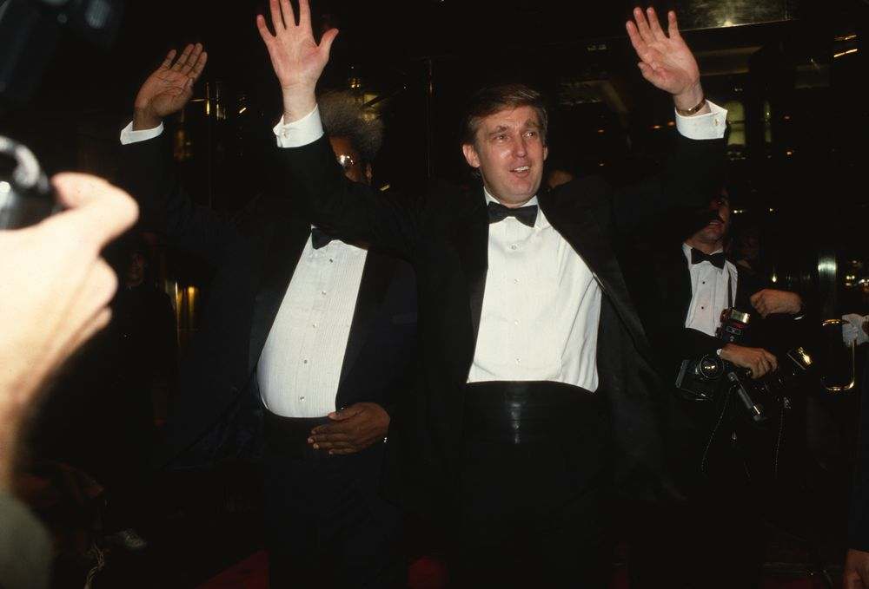Trump at an Art of the Deal book party. (Sonia Moskowitz/Getty Images)
The Art of the Deal was first published in 1987, and it covers the first phase of Trump's life, from birth his then-present. It walks you through his "humble" beginnings in Brooklyn, his "first deal" at Swifton Village in Cincinnati, and his greatest hits, like the construction of Trump Tower in Manhattan.
In Trump's telling, his life is a history of unbroken successes. The experience of reading The Art of the Deal is a bit like that of reading North Korean propaganda, if Kim Jong-Un were obsessed with tax abatements and casino profit margins.
The title, you quickly learn after reading the book, is actually intended to be read more literally than a simple how-to guide: Trump sees deals as a kind of art. His life is a creative enterprise of dealmaking, about joy and self-expression rather than making money. He makes that clear from the book's very first paragraph:
I don't do it for the money. I've got enough, much more than I'll ever need. I do it to do it. Deals are my art form. Other people paint beautifully on canvas or write wonderful poetry. I like making deals, preferable big deals. That's how I get my kicks.
His disinterest in accumulating money for its own sake actually seems genuine. What Trump is concerned about, it's clear, is status.
While his father was a hard-knock guy from Brooklyn, he wants to be a powerful, respected Manhattan dealmaker — with the "best" of everything, from cars to apartments to wives. The point of his business endeavors wasn't to make money; it was, as he puts it, to be known as "more than Fred Trump's son." He's a child of privilege, who inherited assets worth roughly $40 million from his father, but he wanted to make his own name.
"I learned very early on that I didn't want to be in the business my father was in," Trump writes. "He did very well building rent-controlled and rent-stabilized housing in Queens and Brooklyn, but it was a tough way to make a buck. I wanted to try something grander, more glamorous, and more exciting."
"MONEY WAS NEVER A BIG MOTIVATION FOR ME, EXCEPT FOR KEEPING SCORE"
That, for Trump, was Manhattan. He sees the world as full of hierarchies: Manhattan is the most important and famous place in the world, so he had to be there. Once he moved there, he almost immediately tried to join Studio 54, because it was "the hottest club in the city and perhaps the most exclusive." Once ensconced in Manhattan society, he tried to make sure it would never forget him — by building huge buildings and buying the "classiest" stuff.
People are judged similarly, with their appearances and status symbols marking them as worthwhile. Studio 54 was so impressive because "it was the sort of place where you were likely to see a wealthy seventy-five-year-old guy walk in with three blondes from Sweden." To Trump, success is always demonstrated outwardly — it's defined as the ability to show off in a way that marks you as one of life's victors.
"I wasn't satisfied just to earn a good living," he writes. "I was looking to make a statement. I was out to build something monumental — something worth a big effort."
Money, then, isn't important unless it helps buy status; it's a tangible way of showing that Trump is succeeding. "Money was never a big motivation for me, except for keeping score," he writes. "The real excitement is playing the game."
Hence why, in 1987, Trump bought a 727 jumbo liner, a plane designed to fit 200 people, for his personal use. He admits it was an absurd thing to purchase — "it was a little more plane than I needed" — but it was showy ("I don't believe there is any other private plane in the sky comparable to this one"). Moreover, the company that was selling it was having financial trouble, so he could haggle for it and get a good price. "I find it hard to resist a good deal when the opportunity presents itself," Trump writes.
There's a crucial element of struggle to his idea of status, as his metaphor of "playing the game" suggests. Status isn't something that everyone can share; ultimately, someone gets to own the "best" property or the "most beautiful" tower.
"In the end, you're measured not by how much you undertake," Trump writes, "but what you accomplish."
Trump's presidential bid has always seemed kind of baffling to people. It's hard to understand why someone with seemingly no knowledge about public policy, or interest in politics, is trying so hard to obtain a job so historically drenched in those things.
But after reading The Art of the Deal, I think I get it. The presidential election is "the next battle" — now that he's conquered real estate and television, the next way to make his mark is in politics.
I think Trump sees the presidency as the ultimate status symbol, and winning an American election the world's toughest deal to close. And if he wins, there's a whole new set of challenges for him, an even bigger stage on which he can accrue the most stuff and thus prove himself to be the best.

How Trump rationalizes his relationship with the truth
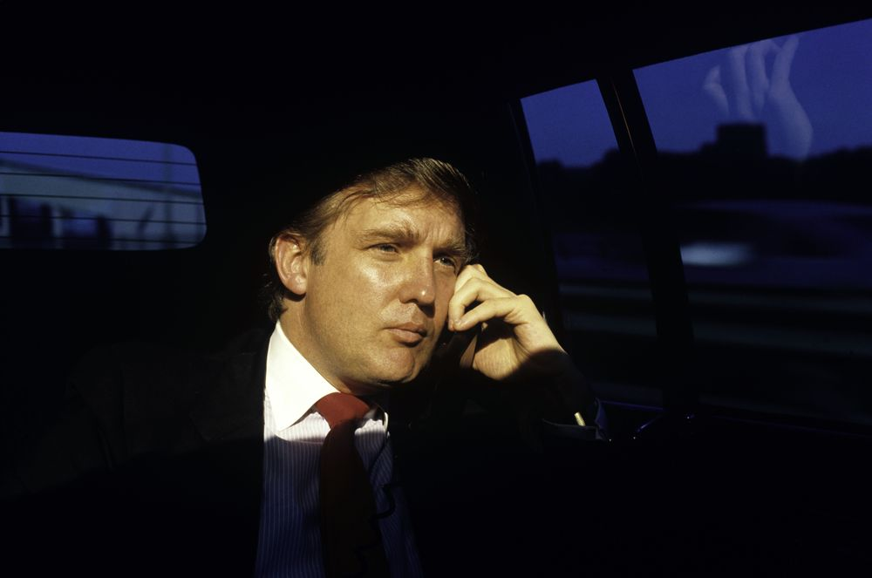1987. (Joe McNally/Getty Images)
Once you start seeing the presidency as Trump's biggest deal, the most tangible proof of his success at life, a lot of the way his campaign is run makes sense. According to PolitiFact editor Angie Holan, who assesses whether politicians are telling the truth for a living, Trump's "record on truth and accuracy is astonishingly poor."
So why, precisely, does Trump lie so much? In The Art of the Deal, he tells us he will do whatever he can to close a deal — the ends justify the half-truth means. Ethics kind of falls by the wayside; the purpose of life is winning, not following the rules. "I'm the first to admit that I'm very competitive and that I'll do nearly anything within legal bounds to win," he writes.
That includes dishonesty. "A little hyperbole never hurts," he writes. "People want to believe that something is the biggest and the greatest and the most spectacular. I call it truthful hyperbole. It's an innocent form of exaggeration — and a very effective form of promotion."
And going beyond "a little hyperbole" has served Trump well. In 1982, he describes how he was trying to get the Holiday Inn corporation to go in as his partner on his first Atlantic City casino. Before Holiday's board members would approve the deal, they wanted to see the site where Trump planned to build it.
Trump was worried that the board would turn him down, as they "had yet to do much work" on building the casino. So he asked his construction crew to round up "every bulldozer and dump truck he could possibly find" and literally pretend to work for as long as the board was on site:
I wanted him to transform my two acres of nearly vacant property into the most active construction site in the history of the world. What the bulldozers and dump trucks did wasn't important, I said, so long as they did a lot of it. If they got some actual work accomplished, all the better, but if necessary he should have the bulldozers dig up dirt from one side of the site and dump it on the other.
Trump recalls one board member asking why "that guy over there is just filling up that hole, which he just dug."
In Trump's eyes, it worked. "The board walked away from the site absolutely convinced it was the perfect choice," he writes. "In reality, I wasn't that far along, but I did everything I could, short of going to work at the site myself, to assure them that my casino was practically finished. My leverage came from confirming an impression they were already predisposed to believe."
This is why Trump lies so much about his policies. He doesn't mind misleading people if it helps him get what he wants — in fact, he believes convincing others that reality is what he says is a critical part of his success.
He's convincing the American public that "it's in their interest to make the deal" — even if his campaign doesn't actually have something they need.

How Trump manipulates the media for profit
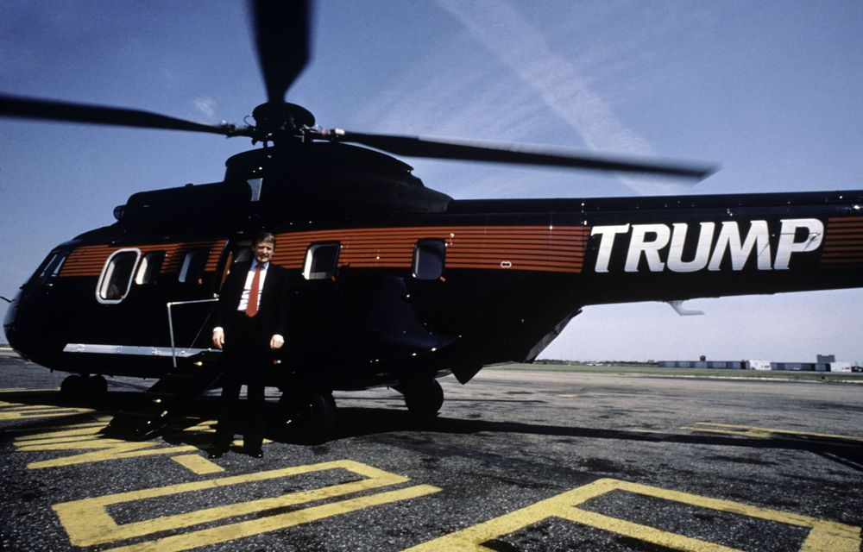Trumpcopter. (Joe McNally/Getty Images)
Many of the most (in)famous moments of Trump's campaign — his feud with Megyn Kelly, his mocking of a disabled reporter, his former campaign manager manhandling then-Breitbart writer Michelle Fields — involve Trump's relationship with the media. An analysis of Trump's Twitter account by my colleague Zachary Crockett found that Trump tweets about the media 3.5 times as much as he tweets about actual policy issues.
There's a reason for that. Throughout The Art of the Deal, Trump constantly talks about reporters and critics: the ones he like, the ones he hates, and the ones who helped his business. For him, media defines reality — and thus who has leverage. He literally attributes one of his most significant successes to the media’s influence: New York’s Trump Tower.
In 1979, before construction began, the Donald's planned crown jewel in Manhattan was in trouble. He was in the midst of a tough battle in the city planning commission, with anti-overbuilding activists deeply opposed to his plans to erect a new skyscraper on Fifth Avenue. Ultimately, Trump won — and he credits the New York Times.
"Looking back," he writes, "perhaps no one had a more powerful influence than Ada Louise Huxtable, then the chief architecture critic of the New York Times."
"CONTROVERSY, IN SHORT, SELLS"
During the fight, Trump courted Huxtable, giving her an exclusive early view of the Trump Tower plans. The review ended up being a pretty negative review of New York zoning laws, with a few compliments thrown in. But the headline — "A New York blockbuster of superior design" — was good enough to convince the commission to approve the plan, Trump believes. "That headline probably did more for my zoning than any single thing I ever said or did," he writes.
The Times's subsequent coverage of Trump Tower was far from positive. In 1980, during the building's construction, Trump ordered his crew to demolish some art deco sculptures that the site's previous owners had installed. The Times's editorial board responded with outrage: "Obviously big buildings do not make big human beings, nor do big deals make art experts."
According to Trump, the widespread anger about the sculpture demolitions didn't actually hurt him. "Even though the publicity was almost entirely negative," he writes, it "drew a tremendous amount of attention to Trump Tower. Almost immediately we saw an upsurge in the sales of apartments."
From this experience, Trump learned that controversy is good for business, as he writes in one of The Art of the Deal's most revealing passages:
I'm not saying that's a good thing, and in truth it probably says something perverse about the culture we live in. But I'm a businessman, and I learned a lesson from that experience: good publicity is preferable to bad, but from a bottom-line perspective, bad publicity is sometimes better than no publicity at all. Controversy, in short, sells.
This, as you can see, has obvious application to his presidential campaign. Trump doesn't mind that the press savages him for wanting to ban Muslims from entering America or for calling Mexicans rapists. He uses the controversy to attract attention, and thus reach the audience that finds his message attractive. His campaign is an exercise in a lesson about media manipulation he learned more than 35 years ago.
"I’m going to suck all the oxygen out of the room," he reportedly told a political consultant before his campaign began. "I know how to work the media in a way that they will never take the lights off of me."
What you have to understand about Trump's faith in the power of the media is that it is near absolute. Trump believes that perception makes reality, and that the media is what determines the world's perceptions today.
Take, for instance, the idea of "location" in real estate. To most people, this means your physical location — homes in desirable neighborhoods are worth more than those in slums. But for Trump, location is socially constructed — a location is valuable if people see it as such, which may not have a lot to do with the physical reality of the location.
"You don't necessarily need the best location. What you need is the best deal," he writes. "Just as you can create leverage, you can enhance a location, through promotion and through psychology."
In selling Trump Tower units, he explains, "we positioned ourselves as the only place for a certain kind of very wealthy person to live — the hottest ticket in town. We were selling fantasy." The heavy media coverage created that fantasy, the mere fact of the attention positioning Trump Tower as "something almost larger than life," an "event" as much as an actual building.
The idea is, in its own Trumpish way, a bit like the one developed by the late French philosopher Jean Baudrillard. In a series of three essays called The Gulf War Did Not Take Place, Baudrillard argued that that the significance of the Gulf War was not principally determined by the physical effects of dropping bombs, but rather by the way warfare was represented in mass media. That's because in a world of 24/7 news coverage, the way things are represented is more important in shaping their effects than the reality of what actually happens.
"Our virtual has definitively overtaken the actual," Baudrillard writes. "We prefer the exile of the virtual, of which television is the universal mirror, to the catastrophe of the real."
Trump has, in an instinctive way, taken Baudrillard's theory to heart. His entire campaign for the presidency is premised on the idea that he can sell himself as "larger than life," that asserting that he has the gravitas necessary to become president will actually bestow it on him. And the press, he believes, are his unwitting accomplices — helping him even as they attack him.

Why Trump can't seem to talk about policy
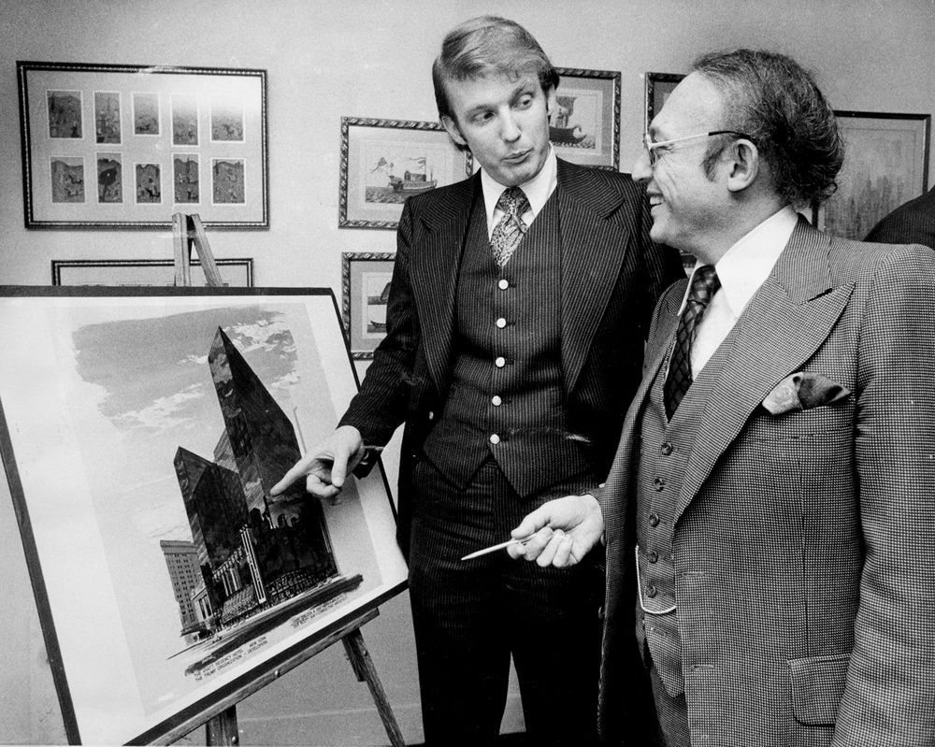1976. (NY Daily News Archive/Getty Images)
One of Trump's strangest features as a candidate is that he doesn't seem to like talking much about policy. His answers to policy questions often involve vague nonsense.
Read one way, this is just simple ignorance: Trump literally doesn't understand the issues in question. When he claims he has a "foolproof way of winning the war with ISIS" but claims he won't release it because "I won’t tell them where and I won’t tell them how" he'll beat them, that's probably what it is. I seriously doubt he has a secret plan that would defeat ISIS but he just won't tell anyone. Trump loves to brag.
But The Art of the Deal suggests a different answer, rooted in what Trump means when he says he wants to hire "the best people." In the context of the book, that comes across not as ignorance but as part of a life philosophy. He sees his bid for the presidency as his life's biggest deal, and is simply executing on the strategy he's used to great success in business.
In the book, as in life, Trump is always talking about working with the "best" people. "I have a very simple rule when it comes to management: hire the best people from your competitors," he writes. "That's how you build a first-class operation."
This approach has helped him fix government projects in the past (or, at least, he thinks it has). In 1986, he took over construction on the Wollman Ice Rink in Central Park. The city had been building it for six years and had gone $12 million over budget without really accomplishing anything.
The issue, Trump writes, was bureaucracy and leadership. "You can get any job done through sheer force of will — and knowing what you're talking about," he writes. "Virtually no one in the city government knows anything about construction. Worst of all, no one in the city government bureaucracy is held accountable for failure."
So when Trump swooped in, he pushed the government out of the way — and applied his patented management strategy.
"Since I myself knew absolutely nothing about building rinks, I set out to find the best skating-rink builder I could," Trump writes. He looked to Canada, because "ice skating is to Canadians what baseball is to Americans." (Trump has a deep faith in stereotypes.) He phoned around and ended up hiring Cimco, a Toronto-based company that had built the Montreal Canadiens' rink.
Cimco did the job well, and the rink was unveiled by November of that year. When it was done, the city asked Trump to manage it. How? "Again, I just looked for the best rink managers available," Trump writes. "The answer I came up with was Ice Capades [and] they've done an impeccable job with Wollman Rink."
This is a running theme throughout the book: When Trump gets sued, he hires the "best" lawyers. When his casinos are struggling, he hires the "best" managers from other companies.
The point is that he sees "hiring the best people" as a legitimate solution to problems with his deals. While most politicians think they themselves are supposed to come up with policy solutions to problems, Trump actually thinks that "hire the best people" is itself a policy solution.
This isn't an original observation. Scott Alexander, the excellent writer behind SlateStarCodex, had a similar thought after reading The Art of the Deal.
"This thing about hiring the best people, for example, seems almost like an obsession in the book," Alexander writes. "When he says that he’s going to solve Medicare by hiring great managers and knowing all the right people, I don’t think this is some vapid way of avoiding the question. I think it’s the honest output of a mind that works very differently from mine."
But there’s an important difference between what Trump means when he says "the best people" and what most people think he means. For Trump, "best" doesn’t necessarily mean the most qualified, talented, or honest: it means the person whose services most benefit Trump, and who will be the most loyal to him personally.
This approach dates all the way back to the beginning of his career, in 1964. Back then, Trump was in college, helping his father manage a 1,200-apartment development called Swifton Village in Cincinnati. Trump and his father were having trouble finding someone to manage the unit, going through manager after manager — until they stumbled upon a man named Irving.
IF YOU READ THE ART OF THE DEAL, THE MYSTERY AROUND TRUMP COLLAPSES
Irving, Trump admits openly, was a con man — and kind of an asshole. In one visit to a tenant’s unit, Irving, according to Trump, instructed a 10-year-old girl to "tell your father to pay his fucking rent or I’m going to knock his ass off." Afterward, he shamelessly flirted with the girl’s (married) mother.
When the incensed husband stormed into the management office, Irving threatened to fight him. "I’ll kill you. I’ll destroy you. These hands are lethal weapons, they’re registered with the police department," he spat.
According to Irving’s employees, he stole a small fund they had all chipped in on together — designed to pay for funerals. Irving stole a lot more from Trump; $50,000 a year, Trump guesses.
A normal person would have fired Irving. Trump came to rely on him. Irving, according to Trump, was "a fabulous man," an "amazing manager," and "one of the greatest bullshit artists I’ve ever met." Trump came to rely on the old man so much, in fact, that he "began spending less and less time" at Swifton Village "once Irving had it running so well."
Trump doesn't care at all that Irving was verbally abusive, or even that he stole from employees. He just cares that Irving helped him turn a profit. Trump doesn't hide this avariciousness — in fact, he brags about it. In his telling, his ability to look past a manager making unwanted sexual advances on a tenant is a sign of his own brilliant business instincts. All that matters to him is that he turn a profit — that Swifton Village end up being, in his parlance, a "good deal."
That’s worth keeping in mind today, given that Trump seems to see his bid for the presidency as just another deal. He's got the same motivation — a hunt for status — and the same principles — manipulate perceptions, hire the "best" people — that he had during his rise to prominence in real estate. This seems bizarre to us, because we aren't used to politicians who act like garish real estate moguls and appoint manifestly unqualified people as their top lieutenants.
But if you read The Art of the Deal, the mystery around Trump collapses. He is exactly who he says he is.

The political science that predicted Trump's rise

Was this article helpful?
VOX “understand the news”

“The political science that predicted Trump's rise”

VOX “The political science that predicted Trump's rise”

